**Programming Assignment 3 – Process Synchronize**

**Jack 1930026143**

**Requirement:**

Designing a Virtual Memory Manager program to transfer the virtual address to the physical address. Here we have the three documents: $Addresses.txt$ includes some virtual address we need t transfer. $correct.txt$ is used to validate whether the result we transfer is correct. And $BACKING_STORE.bin$ file is a random-access file so that we can randomly seek certain positions of the file for reading. When the page table have nothing, the page fault will read the file from the bin file and we can realize that it just a position in the hard disk.

**How to solve question:**

Step1. Read the $Addresses.txt$ and get the virtual memory. Each time we read one line which mean that we use a loop to $fscanf$ the memory. And we use the $fopen$ in C library, we should add the file name as a parameter when we execute the program.



Step2. Get the information of page number and offset. These 16 bits are divided into

(1) an 8-bit page number and (2) an 8-bit page offset. So the first eight digits should be number and the leaf 8 is offset.



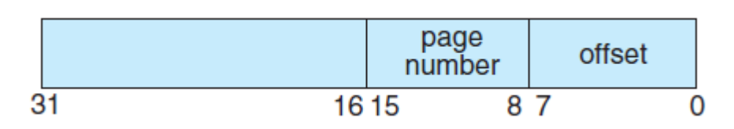

Step3. However, we still have 16 digits should deal with, so we set a judgement statement to select the leaf digits which means that check whether the part in TLB.

Step4. We need a method to read the $BACKING_STORE.bin$ file to get the value. Noted that a physical address is needed to access the main memory. And we should transfer the parameter offset and the number so that the page number can match to page table residing in main memory.

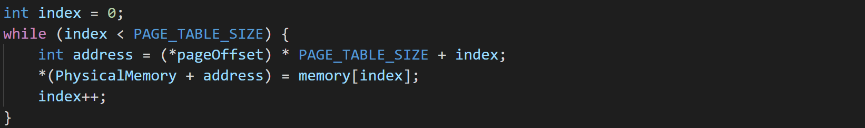

Step5. After corresponding frame number is retrieved, which now tells where in the main memory page lies, store it in the table and update.

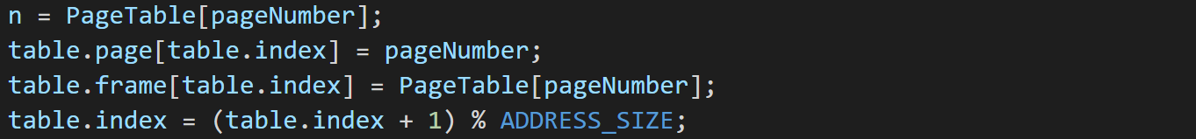

Step6. Statistics, we should get the page fault rate which is the percentage of address references that resulted in page fault and TLB hit rate which is the percentage of address references that were resolved in the TLB. So just use the page fault and the hits number to divide the total memory size.



**Experiment**

1. Use to compile and $./$ to execute the program. Remember to the add the $addresses.txt$ as the $argv[1]$ in the c program. Then here is the result.

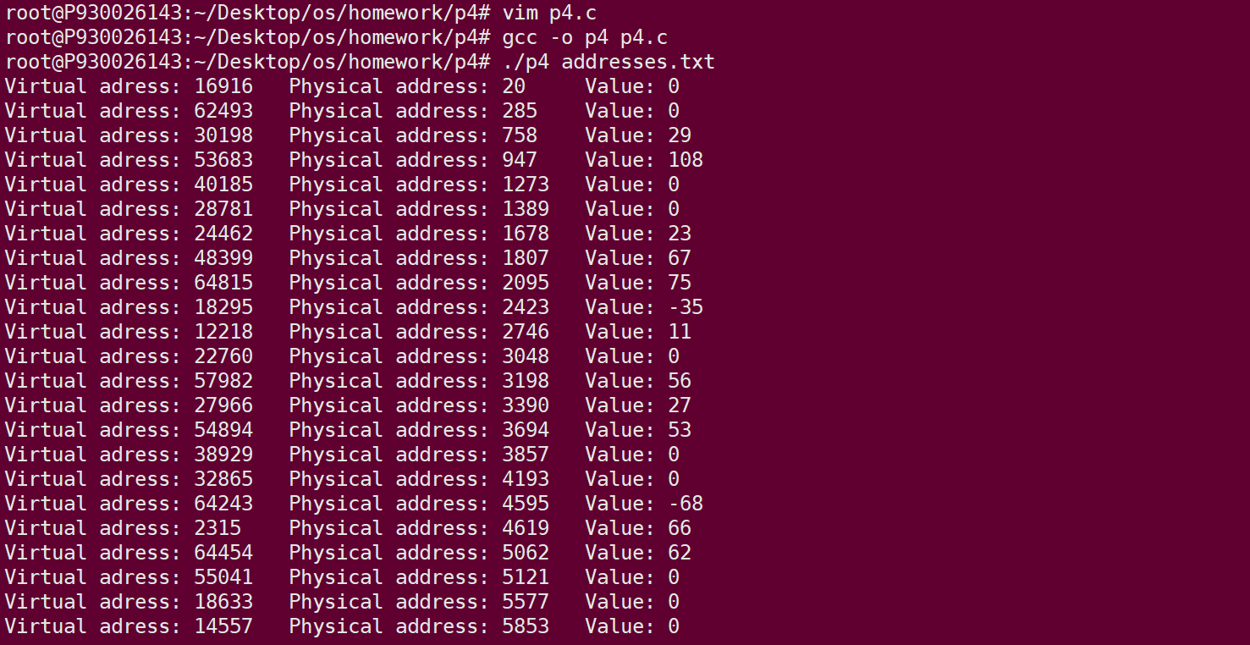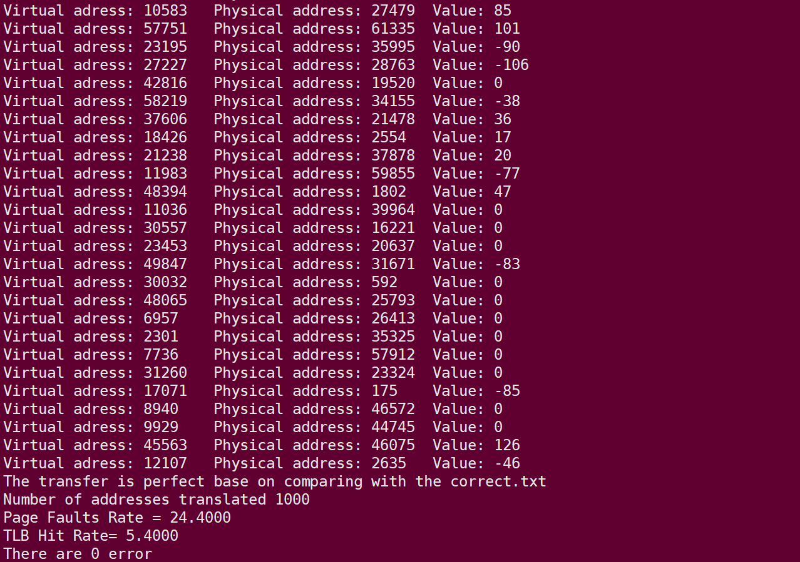

**Problem Encountered:**

1. When I try to get the page number and the offset in the beginning, we just use $≫$ operation to help digits transposition. But the result is not expected one. After browsing some internet material, I know that it should add the $\&$ operation which mean “and” in binary digits and we should $\& OxFF$ which is $1111 1111$.
2. In the table, we should use the $\%$ to find the index. In the beginning, I forget to add so it cannot loop again and again. So we should take over the index and mod address size, In this case, we get the values are all 0.